cd CloudFormation/
ls
514 git add instance-s3-creating-ymlfile.yml s3-bucket-createing.ymlfile.yml
515 git status
516 git commit -m "s3bucket-instance-ymlfile"
517 git status
525 git remote -v
526 git remote remove origan
527 git remote remove origin
528 git remote -v
529 git remote add origin https://github.com/yatheesh-k/CloudFromation.git

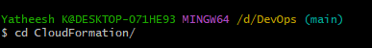

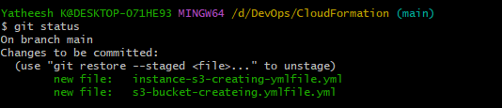

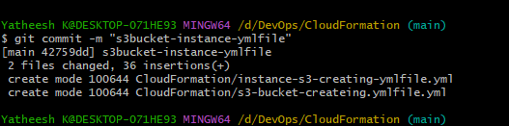

This not my repo change to the repo,
Remove to the origin,
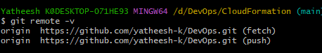

Remote remove origin,
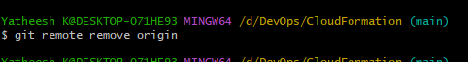

Check origin main,
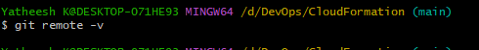

Git add origin, add your repo url,
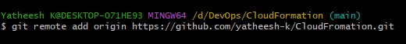

Check your origin ther or not,
